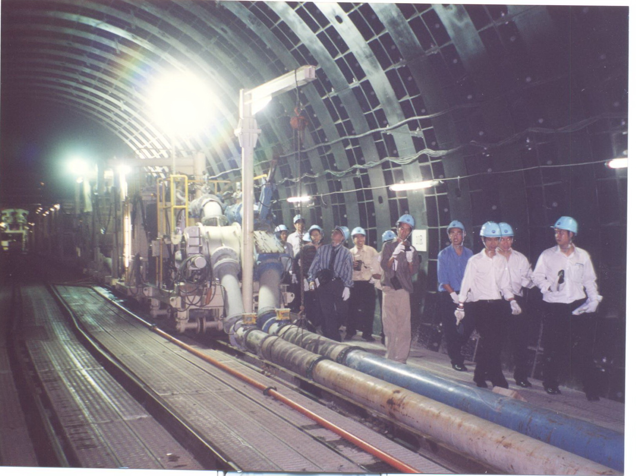
M.Eng. in Civil Engineering at KU
English Program
Apply now until 31 August 2012 (For September 2012 Semester)
Why join us?
- Widely recognized program with over ten-year track record
- Excellence in research and academics / visiting professors
- International environment
- Hands on experience through industry collaboration
- Reasonable tuition fee with financial supports available
- Free supplemental English Course (48 hrs)
- Wise choice for those who are seeking career success in ASEAN and worldwide
“A Brighter Future Awaiting You”
Call us now at 081-8115184 or E-mail fengaru@ku.ac.th for more details
or visit us at http://www.ceinter.eng.ku.ac.th/

